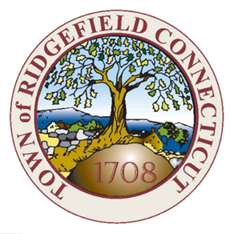
Town of Ridgefield
Blight Prevention Board Meeting

CANCELLED MEETING NOTICE

October 20th at 11:00 am

The regularly scheduled meeting on October 20th at 11am has been cancelled.

Renee Petrillo
Blight Prevention Board Secretary

